**US-wide superstore sales analysis and dashboard**Author: Federico Hartmut Garland Schiefer

**OBJECTIVE**  
The objective of this project was to analyze the sales of a US superstore to obtain useful insights for the decision-making process and business growth. Specifically, the goal was to identify areas of improvement for the optimization of sales strategies through measuring the year over year growth or decline of different sales metrics and key performance indicators (KPIs), such as total revenue, average ticket value, units per transaction, among others, categorized by different groups, such as product category, subcategory, etc. For this, an interactive Power BI dashboard was created.

**METHODOLOGY  
Tools used**   
- Power BI   
- Excel   
  
**Process**  
- Dataset selection and download   
- Data import to Power BI (using Power Query)   
- Dashboard design and DAX measures in Power BI  
  
**Detailed methodology  
1. Data selection and download**Sales datasets were searched for in Kaggle. Among these, the superstore sales dataset had the necessary time range and variables (both categorical and continuous) needed for this project, so it was downloaded as a CSV file.  **2. Data import**  
The dataset was loaded to Power BI using Power Query, where the data was further cleaned by eliminating unnecessary columns and assigning correct data types to the remaining ones.

The data modelling did not need the use of a star schema since the dataset was comprised of only one fact table, with no dimension tables. Thus, best practices like not using bidirectional filtering to avoid ambiguity or bridge tables for many to many relationships weren’t needed.   
A calendar table was created, and a relationship was established with the sales dataset’s “Order Date” column to be able to properly use time intelligence functions. **3. Dashboard design and DAX measures in Power BI**   
First, several KPIs were chosen: Revenue, Sold Units, Customer Count, Amount of Orders, Average Ticket Value (ATV) and Units Per Transaction (UPT). These KPI’s were selected because they all influence the business’ profitability and growth, and their results offer actionable insights for the decision-making process and the design of sales strategies.   
For example, a decline in Units Per Transaction could warrant strategies such as bundle deals (e.g. “Buy 3 or more products for a 10% discount”), upselling, cross-selling and others, which would help maintain or increase the business’ profitability.   
  
Therefore, multiple measures were created using DAX functions to determine the values of the KPI’s in the current year and compare them with the values in the previous year, in the selected filter context (total or by state, city, segment, category, subcategory, etc.). All measures were stored in a Measure table and can be found on the .pbix file. In addition, a calculated column was created to classify products as “Low Price” (price < 30% of all product average), “Medium Price” (price between 30 and 60% of all product average) and “High Price” (price > 60% of all product average).

DAX functions used include CALCULATE, time intelligence functions, conditionals, rank functions, year over year variations, among others. Variables were also defined within measures to optimize performance and reduce complexity.

A two-page report was created, MTD (Month to Date) and YTD (Year to Date). The MTD page shows the cumulative sales indicators from the first day of the month to the last day with sales (current date) in the same month, whereas the YTD page shows the cumulative sales indicators from the first day of the company’s fiscal year to the last available date of the fiscal year (current date). The fiscal year chosen for the company runs from october to september, as does the US federal government’s fiscal year.   
Both pages compare the values of sales for the maximum day of the month in the current year, with the values for the same day in the same month but in the previous year. For example, if “December” is selected which only has data up to the 15th day, then all growth rates show the comparison between December 15 Current Year vs December 15 Previous Year. The only difference is in the start of the cumulative sum (1st day of month for MTD page and 1st day of fiscal year for YTD page).   
  
Visuals selected were slicers (which filter the report), cards, line charts, bar charts and tables.

Finally, the report was analyzed to elaborate a brief summary of the most relevant insights at the month-to-date and year-to-date level. Abbreviations used to shorten repetitive words can be found on the annexes at the bottom of this README file.

**RESULTS**YTD level  
  
* Revenue grew 25%, all other metrics except for ATV and UPT increased by around 30-40%, with the highest increase on the amount of orders (42%).
* Average Ticket Value (ATV) and Units per Transaction (UPT) fell by 12% and 2.5% respectively, indicating that even though the amount of orders has increased, each order is generating on average less revenue and being comprised of less units than last year. This decline in ATV and UPT explains why while all other metrics increased by 30-40%, total revenue increased by just 25%. Focus should be placed on increasing these two metrics to drive revenue growth.
* The decrease in ATV can only be partly explained by a decrease in UPT since ATV decreased by 12% and UPT by just 2.5%. Other influencing factor seems to be the price of the sold units, since the amount of units sold of the “High Price” group increased by just 34%, whereas the “Medium Price” and “Low Price” groups saw their sales increase by 36% and 41% respectively.   
  At a proportional level, Low Price products represent 55.7% of sold units in the current year, while they comprised 54.5% of units sold last year. On the other hand, High Price products constitute 31% of current year sales, while they constituted 32% of units sold last year. So, the proportion of Low Price products sales has grown, and that of High Price products has dropped.   
  This indicates that the cause of the ATV drop is that for each transaction less products are being bought, and on average the bought products have a lower price.
* Drilling down, ATV experienced the greatest decline in the Office Supplies category (-27%), with the sub-category Binders dropping by 40%. This is mainly explained by price, since Binders sales of Low-Price products increased by 30% and High Price products sales dropped by 30%. The state where sales of Binders of High Price dropped the most in was New York (-50%). All of this has caused Binders revenue to be around 7000 $ less than last year.
* However, considering only subcategories, Copiers experienced the greatest drop in ATV (-2236 $ per transaction), whereas for UPT the greatest drop was seen in Labels (-8%).
* At a state level, the biggest ATV decline happened in Rhode Island, Nevada and Indiana. In Rhode Island, Providence caused the reduction with Copiers being the most influential products in the decline (-5400 $ per transaction), with the product “TEC-CO-10001449” accounting for this drop.   
    
  MTD  
    
  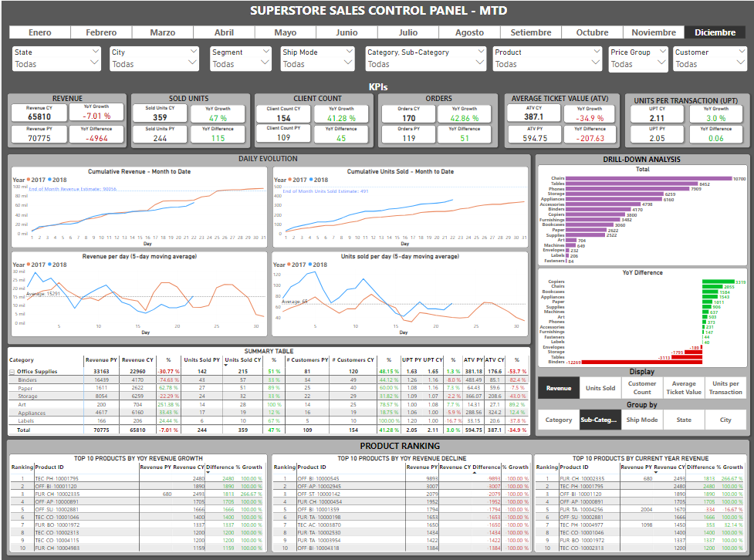
* At the current sales speed in December, the revenue by the end of month would be 86’593 $, which would represent a -9.5% decrease in relation to last year’s revenue for December.
* As for the 22 already transcurred days, Sold Units, Customer Count and Orders all increased by 41-47%, with UPT increasing by 3%, in relation to the same period last year. However, Revenue and ATV dropped by 7% and 35% respectively. This can be explained by the decline in purchases of High Price products by 14%, accompanied by a subtantial increase in purchases of Low Price and Medium Price products by 69% and 83% respectively. This indicates that even though there were more customers, sold units, orders and units sold per transaction, these were of lower priced items.
* The category Office Supplies fell by around 10 000 $ in revenue, with the subcategory Binders losing 12 000 $, which also had the greatest ATV decline (-82%). This is also explained by a decrease in purchases of High Price products (-36%) as well as units per transaction (-8%).

- At a state level, revenue dropped the most in Michigan with around 9000 $ (-70%), with ATV also experiencing the greatest drop in this state (-76%), even though all other metrics including UPT increased. This can be explained by the decline in orders of High Price products, which fell by 33%. This means that even thought there are more orders comprised of more units, these are lower priced products.   
  
- The city that caused this diminishment in Michigan was Detroit, with the subcategory Binders being the most affected, particularly the product OFF-BI-100000545.

**CONCLUSIONS**

* Revenue and most key metrics have increased, indicating a good general sales performance. Still, revenue could have increased further if ATV and UPT had not dropped.
* Each transaction is generating less revenue because it is comprised of less units and those units tend to have a lower price. Focus should be placed on strategies to increase the Average Ticket Value and Units Per Transaction, such as upselling (encouragng customers to buy higher-priced products, increasing ATV), cross-selling (encouraging customers to buy completementary products, increasing UPT and in turn ATV), bundle deals (discounts for a certain purchase value treshold, buy 3 take 1 for free, etc.), among others.
* These strategies would be best applied to products in the Binders, Copiers and Labels subcategories, and in places like New York (for Binders), Indiana and Rhode Island (for Copiers) and Oregon (for Labels).
* The control panel should be further inspected and analyzed in order to extract more relevant insights for the design of commercial strategies, leading to higher revenue.
* Effects of prices on the outcome of other metrics could also be assessed by calculating an average product price, instead of using categories like the ones used in this particular analysis (High Price, Medium Price, Low Price). Furthermore, the categories could be further improved by calculating them according to the average price of each grouping (category, sub-category, etc).

**ANNEXES**Abbreviations used in the report:   
CY = Current Year  
PY = Previous Year  
YoY = Year over Year   
ATV = Average Ticket Value   
UPT = Units Per Transaction   
MTD = Month to Date   
YTD = Year to Date